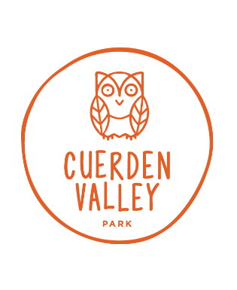
Zero Waste Challenge

This year we are trying to reduce the amount of waste produced by schools visiting Cuerden Valley Park. We are asking all schools visiting us to take on our Zero Waste Challenge to support this drive and to produce and leave behind as little waste as possible, following lunch in our classroom facility.
Some ideas for how to achieve this:
- Bring lunches in rucksack or other reusable bag instead of plastic or paper bags (bags will be safely left in our classroom whilst we are out on the park).
- Bring drinks in re-usable drinks containers, rather than throw away bottles.
- Put sandwiches/biscuits/cakes etc in re-usable sandwich boxes, not wrapped in cling film or foil.
- Ask parents not to pack too much unnecessary food (we have noticed a lot of completely untouched food goes in the bin).
- Show children photographs online of The Pacific Garbage Patch and investigate some websites about recycling (there are a couple of ideas below).
We will provide a certificate for schools that successfully meet the challenge and your school will appear on our wall of fame zero-waste board.
It can be done – some schools have already adopted this policy for all school trips, reducing their waste load very significantly.

Thank you for supporting us in this.

