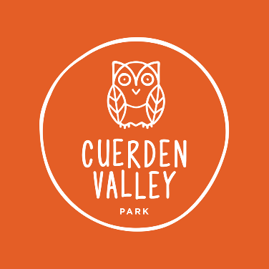

JOB DESCRIPTION

JOB TITLE: Engagement & Communication Officer
RESPONSIBLE TO: CEO
RESPONSIBLE FOR: No line reports. Operational annual budget of no more than £50,000
LOCATION: Cuerden Valley Park Trust office, Visitor Centre, Berkeley Drive, Bamber Bridge, Preston PR5 6BY
SUMMARY OF ROLE: The Engagement & Communication Officer (ECO) has lead responsibility for improving the communication and engagement of the Education, Volunteering and Visitor Experience activities of the Trust such that CVPT becomes a highly regarded destination venue locally and regionally. The new postholder will help shape and broaden our engagement with Visitors and our digital and online content. You will ensure compliance with GDPR and other relevant legislation such that our online presence is of the highest standards and reaches the optimum audiences.
HOURS: Full time (based on 37.5 hours) over 5 days (Mon-Fri). There may be a requirement for weekend working and a degree of flexibility will be required. Time off in lieu of extra hours worked will be given. Flexible hours and Job Share will be considered. This post may be suitable for some home-working.
SALARY: £24,000 (FTE based on 37.5 hours)
PENSION: The post holder will be eligible for employer’s contributions of 5% to a private pension scheme providing the employee contributes at least 3%.
CONTRACT: This is a regular, permanent contract.
PROBATION: There is a six-month probationary period for this post.
PAID LEAVE: 23 days per annum initially pro rata (excluding public holidays).

Role purpose:
- Promote the Trust’s brand and core values around conservation, environment and education
- Increase engagement with our visitors and supporters, growing our following across the region
- Develop online fundraising opportunities and campaigns to increase revenue and raise awareness
- Liaise with the Friends of the Park to expand membership and engagement
Key tasks:
- Identify, reach and engage with relevant professional communities, schools and community groups to raise the profile of our events, facilities and services.
- Develop and implement the Trust’s Communications Plan via the creation of a social media marketing strategy to engage with target audiences
- Maintain the Trust’s website and social media channels
- Maintain the corporate brand and oversee production of all print media
- Work with key staff to generate ideas, promotions and content for the social media channels and campaigns
- Take part in practical activities in collaboration with the Lead Ranger, Commercial Manager and Education Manager to promote and deliver an agreed programme of events and activities.
- Promote the Cuerden View Café brand
- Monitor and respond to customer generated reviews online (e.g. Tripadvisor)
- Identify opportunities for creative online fundraising campaigns and evaluation of their success.
- Monitor and report levels of engagement across web and social media (Google analytics etc).
- Produce other forms of print media such as banners and posters as required, either in house or externally.
- Ensure all forms of media and marketing materials are of a high quality and consistent with the Trust’s corporate brand and core values.
- Produce audience ready copy for press and other media channels
- Respond to media enquiries.

Person specification
Qualifications: Environment, Marketing or related Degree, Marketing Qualification/Apprenticeship or equivalent experience at a similar level in a similar role.
Experience in a charity, visitor attraction or conservation environment.
Skills & abilities:
- Experience of leading practical events and activities with visitors and volunteers within an environmental/learning/conservation-based charity or similar organisation.
- At least 2 years’ Experience in the environmental sector creating marketing and communication materials across a variety of social media platforms
- Strong understanding of social media tools and functionality
- Editorial ability to grasp sensitive or competing issues around nature, conservation, visitor management, finance etc.
- Strong digital skills including WordPress or other Content Management Systems
- Creative eye for strong images and attention to detail
- Strong IT Skills
- Copywriting & Proof Reading
- Experience of analysing data and producing reports
- Experience of liaising with designers, printers & other stakeholders.
- Ability to communicate
- Good team player
Updated: September 2022

